|  |  |  |  |  |  |
| --- | --- | --- | --- | --- | --- |
| Date | 24-Nov-22 | | | Tester Name | Mayuri Patel |
| Environment | Penfax - Test | | | Login used |  |
| Operating System | Select OS | Version: | Update: | | |
| Software Used | Select Software | Version: | Update: | | |
| Select Software | Version: | Update: | | |
| Release version | 22.4.1 | | | | |
| Title |  | | | | |
| Test Type | Regression | | | | |
| Test Scenario | Remove a Beneficiary | | | | |
|  |  | | | | |
| Expected Results |  | | | | |
| Pass/Fail | Pass | | | JIRA# | N/A |

Describe your steps with screenshots:

Search for any MEPP member that have beneficiary listed.

Under Person Profile🡪Beneficiary🡪Beneficiary Designation

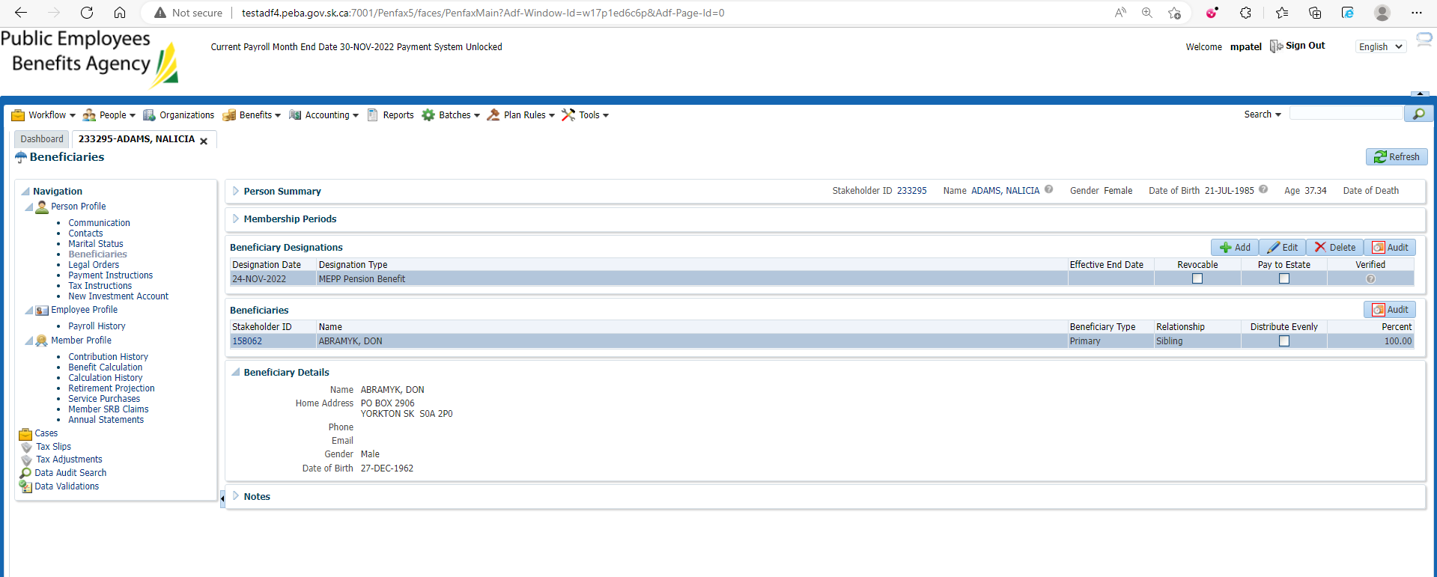

Delete Beneficiary Designations

Confirm Delete

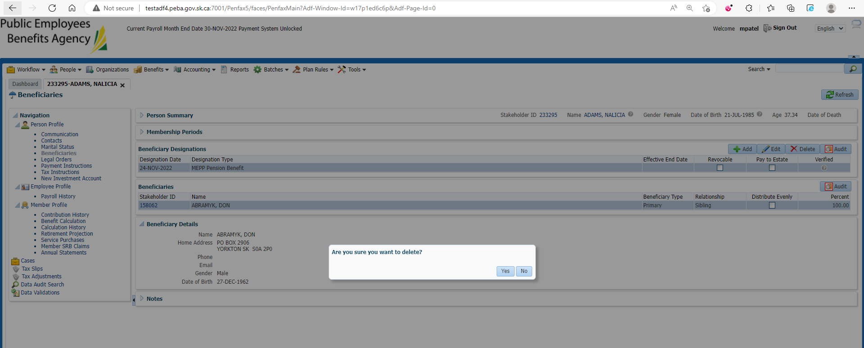

Beneficiary is now deleted

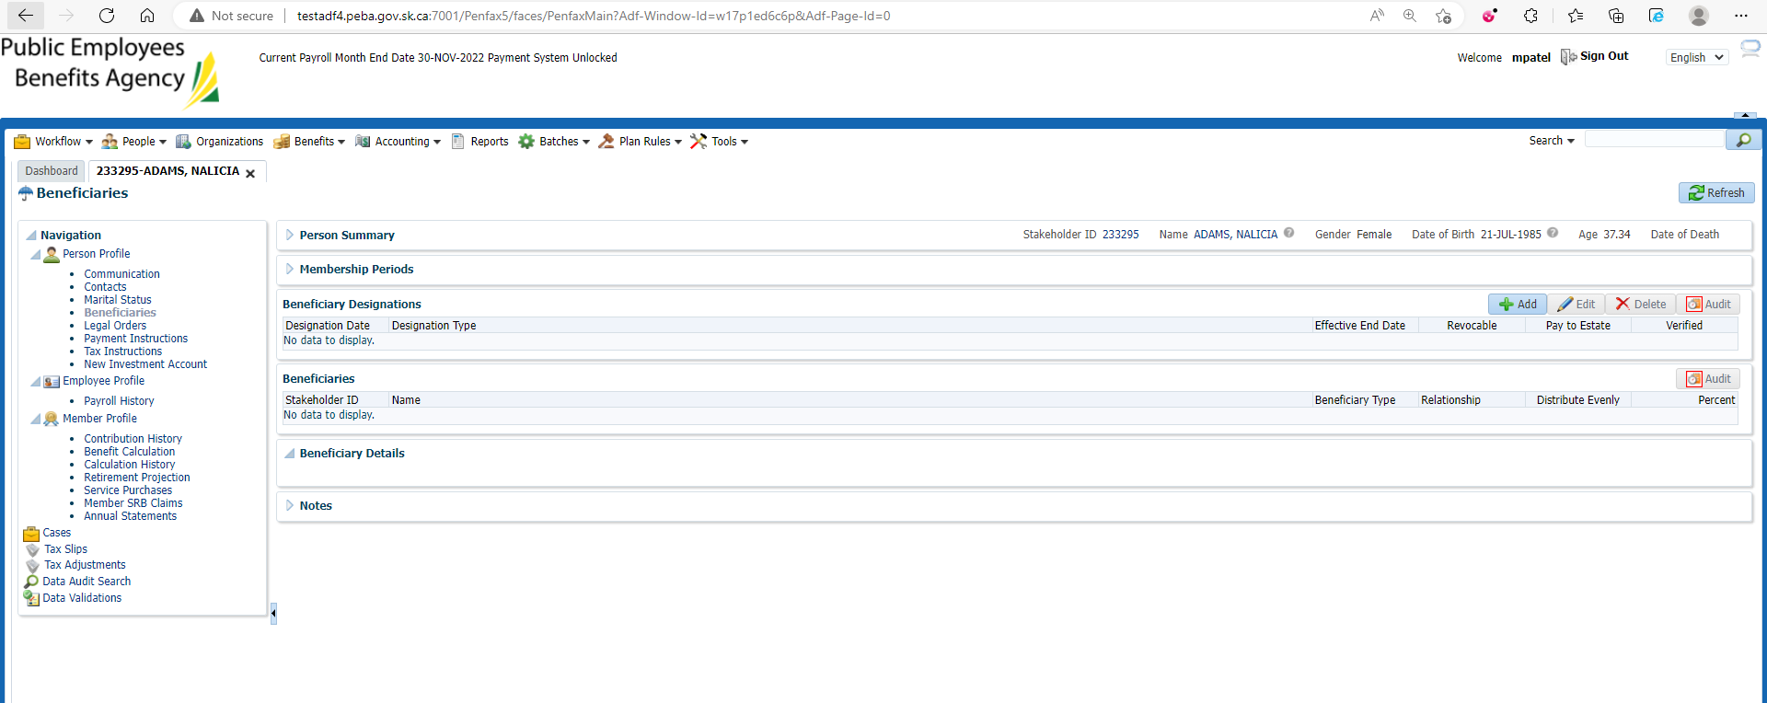

Changes are reflected in Pen web

